Computer Programming Lab – 4

1. Write a C program to print day of week name using switch case.

#include <stdio.h>

int main()

{

int num;

do

{

printf("Enter a number: ");

scanf("%d", &num);

switch(num)

{

case 1:

printf("Monday");

break;

case 2:

printf("Tuesday");

break;

case 3:

printf("Wednesday");

break;

case 4:

printf("Thursday");

break;

case 5:

printf("Friday");

break;

case 6:

printf("Saturday");

break;

case 7:

printf("Sunday");

break;

default:

printf("Enter a number 1-7 \n");

}

}

while(num>7);

return 0;

}

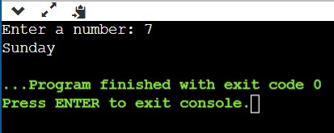

2. Write a C program print total number of days in a month using switch case.

#include <stdio.h>

int main()

{

int num;

do

{

printf("Enter a number: ");

scanf("%d", &num);

switch(num)

{

case 1:

printf("January has 31 days");

break;

case 2:

printf("Feburary has 28/29 days");

break;

case 3:

printf("March has 31 days");

break;

case 4:

printf("April has 30 days");

break;

case 5:

printf("May has 31 days");

break;

case 6:

printf("June has 30 days");

break;

case 7:

printf("July has 31 days");

break;

case 8:

printf("August has 31 days");

break;

case 9:

printf("September has 30 days");

break;

case 10:

printf("October has 31 days");

break;

case 11:

printf("November has 30 days");

break;

case 12:

printf("December has 31 days");

break;

default:

printf("Enter a number 1-12 \n");

}

}

while(num>12);

return 0;

}

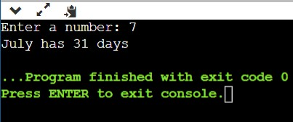

3. Write a program using switch case where user will enter 3 values (2 operands and 1 operator) and program will print the output after processing the operands using given operator. (Calculator)

#include <stdio.h>

int main()

{

int num1, num2;

char chr;

printf("Enter a operator (+,-,\*,/): ");

scanf("%c", &chr);

printf("Enter a number: ");

scanf("%d", &num1);

printf("Enter a number: ");

scanf("%d", &num2);

switch(chr)

{

case '+':

printf("%d %c %d = %d", num1, chr, num2, num1+num2);

break;

case '-':

printf("%d %c %d = %d", num1, chr, num2, num1-num2);

break;

case '\*':

printf("%d %c %d = %d", num1, chr, num2, num1\*num2);

break;

case '/':

printf("%d %c %d = %d", num1, chr, num2, num1/num2);

break;

default:

printf("Enter a valid operator\n");

}

return 0;

}

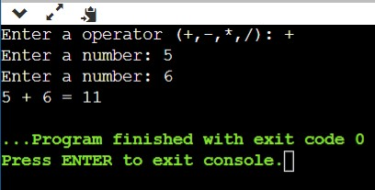

4. Write a program to enter the ship name based on the character entered. If it is B or b Battleship If it is C or c Cruiser If it is D or d Destroyer If it is F or f Frigate If it is not any of the letter print unknown ship

#include <stdio.h>

int main()

{

char chr;

printf("Enter a alphabet: ");

scanf("%c", &chr);

switch(chr)

{

case 'B':

case 'b':

printf("The name of the ship is Battleship");

break;

case 'C':

case 'c':

printf("The name of the ship is Cruiser");

break;

case 'D':

case 'd':

printf("The name of the ship is Destroyer ");

break;

case 'F':

case 'f':

printf("The name of the ship is Battleship");

break;

default:

printf("The name of the ship is unknown");

}

return 0;

}

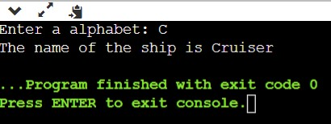

5. Write a C program to display user details using their id. Details: Name, Id, Contact Number, Address. Id range: (Roll no – 2) to (Roll number+2)

#include <stdio.h>

int main()

{

int num;

do

{

printf("Enter the roll number: ");

scanf("%d", &num);

switch(num)

{

case 15:

printf("\nName: Ananya");

printf("\nId: CB.EN.U4CYS21015");

printf("\nContact Number: +91 89177 39370");

printf("\nAddress: Shastri Hall, Nana Chowk, Grant Road");

break;

case 16:

printf("\nName: Devesh");

printf("\nId: CB.EN.U4CYS21016");

printf("\nContact Number: +91 61279 19379");

printf("\nAddress: 1005-b, Panchhatna, M P Road, Opera House");

break;

case 17:

printf("\nName: Nitn");

printf("\nId: CB.EN.U4CYS21017");

printf("\nContact Number: +91 61279 21631");

printf("\nAddress: 1206a, Raheja Centre, Free Press Rd, Nariman Point");

break;

case 18:

printf("\nName: Shrishti");

printf("\nId: CB.EN.U4CYS21018");

printf("\nContact Number: +91 88477 74660");

printf("\nAddress: 54, Mount Poonamallee Road, St Thomas Mount");

break;

case 19:

printf("\nName: Skyler");

printf("\nId: CB.EN.U4CYS21019");

printf("\nContact Number: +91 61279 44062");

printf("\nAddress: 11/2, New Railway Road Cho");

break;

default:

printf("Enter a number 15-19 \n");

}

}

while(num>19 || num<15);

return 0;

}

